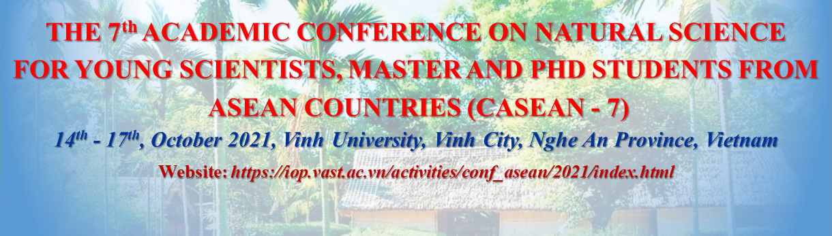
THE 7th ACADEMIC CONFERENCE ON NATURAL SCIENCE
FOR YOUNG SCIENTISTS, MASTER AND PHD STUDENTS
FROM ASEAN COUNTRIES (CASEAN - 7)
October 14-17, 2021, Vinh University, Vinh City, Nghe An Province, Vietnam
Personal Information
First name |  | Last name
Position | ( ) Professor ( ) Ph.D ( ) Researcher ( ) Lecturer  ( ) Ph. D. Student ( ) M.Sc. Student ( ) Other
Institute
(School)
Address
Nationality |  | E-mail
Phone |  | Cell phone
Type of Participation | ( ) Submitting an abstract for plenary/invited talk  ( ) Submitting an abstract for contributed talk  ( ) Submitting an abstract for poster presentation  ( ) Only attending the Conference
Requirements & Comments
If you are vegetarian, please comment it here.

