# DETECTION OF NITRIC OXIDE AT LOW CONCENTRATIONS BY DIFFERENTIAL ABSORPTION SPECTROMETRY USING A FULLY-DIODE-LASER-BASED ULTRAVIOLET LASER SYSTEM

## Lemthong Lathdavong1*, Jie Shao2 and Ove Axner3

*1 Department of Physics, National University of Laos*

*2 Institute of Information Optics of Zhejiang Normal University, China*

*3Umeå University, Sweden*

*\**E-mail*: lemthong2009@gmail.com*

**Abstract.** Detection of nitric oxide (NO) by absorption spectrometry (AS) has for long been hampered by lack of lasers working in the infrared (IR) wavelength region where the NO molecules have suitable vibrational transitions (fundamental vibration at ~5.3 µm, first and second overtone at 2.65 and 1.85 µm). In addition, the overtone transitions are weak. In order to address this problem, the NO molecule has been detected on one of its electronic transitions in the ultraviolet (UV) region by a specially designed fully diode-laser–based laser system that is capable of producing mW powers of light at the strongest X2Π(v"=0)-A2∑+(v'=0) transition at around 226.58 nm. It was demonstrated that NO could be detected down to 3 path per million meter (ppb·m) under low pressure conditions by differential absorption spectrometry, which is two orders of magnitude below that of any other diode-laser-based absorption technique. The combined linestrength of the targeted lines was assessed to 3.1×10-18 cm-1/(molecule cm-2), which supersedes typical linestrengths of the fundamental vibrational band and the first and second overtone bands of NO by ~2, ~3, and ~5 orders of magnitude, respectively. Also the collision broadening and shift of the targeted lines in NO by N2 were assessed.

1. **INTRODUCTION**

Nitric oxide (NO), which is the most abundant species of the environmentally hazardous nitrogen oxides (NO*x*), is a reactive and strongly toxic pollutant that gives rise to direct health effects, contributes to ground-level ozone, and causes acid rain. It is therefore of importance to minimize its formation as well as presence in the environment. Permissible emission of NO levels is facing increasingly strict regulations [1].

The NO molecule has its strongest vibrational absorption band (the fundamental band) in the mid-IR part of the spectrum, at around 5.2 μm, whereas its first and second overtones appear in the short wavelength IR region, at approximately 2.65 and 1.8 μm, respectively. For diatomic molecules, the first overtone band is in general around 2 orders of magnitude weaker than the fundamental band, whereas the second overtone is yet another order of magnitude weaker than the first. Detection of NO at the two overtone bands therefore suffers from weak absorption cross-sections. The transitions in these bands are also strongly affected by interferences from other constituents, primarily H2O. In addition, there have so far not been any commercially available reliable “standard” diode lasers in these wavelength regions. All this has made detection of NO by diode-laser techniques problematic. This is manifested by the rather moderate detection limits that have been reported for detection of NO by TDLAS/WMAS on the first and second overtones [2-9].

In this work provides a first laboratory-based demonstration and an assessment of the potential of a fully diode-laser-based system for detection of NO on itsX2Π(v"=0)-A2∑+(v'=0) band at ~226.6 nm utilizing milliwatt powers of UV light. The instrumentation is built around a commercially available diode-laser-based system that can produce cw UV light suitable for detection of NO at milliwatt powers. It is shown that by access to UV light at these powers, NO can be detected by direct absorption spectrometry under low-pressure (Doppler broadened) conditions in the low ppb·m range by a simple differential mode of detection.

1. **EXPERIMENTS**

The experimental set-up is schematically illustrated in Fig. 1. The UV laser system was purchased from a commercial supplier as a fully integrated system to our performance specifications for the particular purpose of detection of NO in the 226-227 nm region. The system is mounting up on a common base plate with all electronics conveniently gathered in a set of racks. The heart of the system is an external cavity diode laser in an external external cavity diode laser produce 40 mW of continuous-wave light around 907 nm. The light passes an optical isolator before being fed into a tapered amplifier (TA), producing light at powers of around 700-800 mW. This light is fed into an external cavity, locked to the frequency of the laser by the Pound-Drever-Hall technique and containing a KNbO3 crystal, that produces light at around 453 nm with an output power of around 300 mW. This light is, in turn, fed into a second external cavity, locked to the frequency of the laser by the Hänsch-Coulliaud technique and containing a BBO crystal, that in general produces light around 226.6 nm at output powers of a few mW (up to 10 mW, depending on wavelength). The UV power of the laser is regulated by a “noise eater” consisting of two feedback systems; one “slow”, regulating the current to the diode, and one “fast”, directly affecting the tapered amplifier.

The UV light was split into two beams by the use of a thin beam-splitter (OS6); one passing through the sample cell before it was directed to a detector (D5), referred to as the analyte signal beam, and one aimed directly to another detector (D6), called the background signal beam. The detectors used were two GaP UV-enhanced photodiodes (D5 and D6). The outputs from the two detectors were sent to a 2-channel transimpedance detector amplifier board (TIDA) that converts the photocurrents to voltages. The board can provide gain in the 105~107 V/A range but was run with lowest possible gain to avoid overload. The output voltages from each channel were filtered and amplified using two combined low-pass filters and preamplifiers (PA1 and PA2) prior to digitization on a personal computer equipped with an A/D card and LabVIEW software.

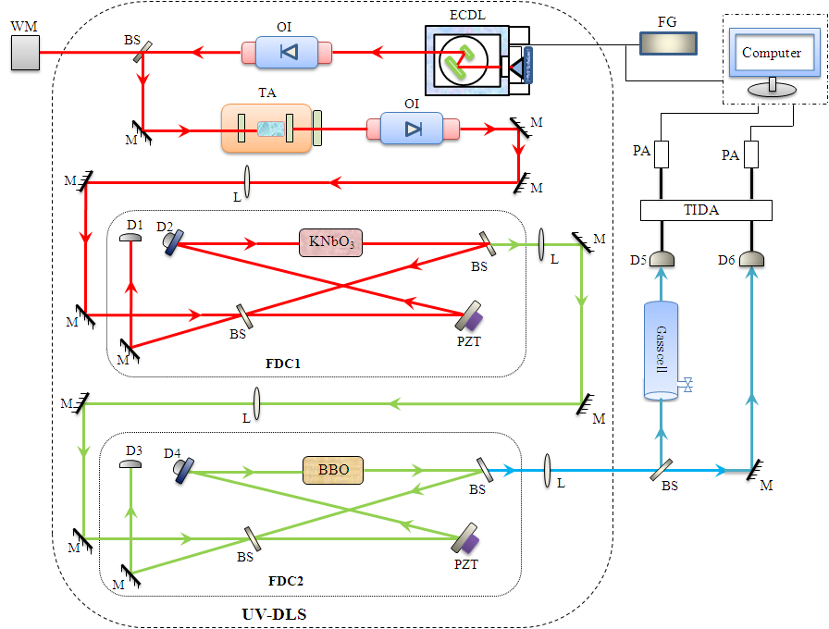

**Fig. 1**. *Schematic of the instrumentation. FG, function generator; ECDL, external cavity diode laser; OI, optical isolator; OS, optical splitter; M, mirror; TA, tapered amplifier; L, lens; PZT, piezoactuator; D, photo detector; KNbO3, potassium niobate frequency-doubling crystal; BBO, β–barium borate frequency-doubling crystal; FDC, frequency-doubling cavity; TIDA, transimpedance detector amplifier; PA, preamplifier; WM, wavelength meter. The parts within the solid curve constitute the UV-DLS*.

1. **RESULTS AND DISCUSSION**

For each experiment, the center wavelength of the ECDL was first tuned to the vicinity of 906.30 nm by the use of a wavemeter, to produce UV radiation around the targeted NO transitions at 226.58 nm. The UV light was then tuned back and forth across the selected transitions by modulating the piezocrystal transducer in the ECDL laser in a sinusoidal manner by a function generator at a rate of 1 Hz. The scanning range was typically 38 GHz (1.3 cm-1) in UV, which is slightly more than ten times the Doppler width of the NO transition (FWHM 2.98 GHz). The data acquisition rate was 6 kHz.

To provide an accurate wavelength scale for the measurements, the frequency scan of the laser was calibrated by scanning the laser with a given sinusoidal voltage with the last external cavity unlocked. The longitudinal cavity modes, which were spaced by 0.076 cm-1 (2.28 GHz) in UV according to a separate calibration utilizing the wavemeter, served as accurate frequency markers. One such scan is displayed in Fig. 2 (the sharply peaked curve) together with the output voltage of the function generator (the sinusoidal curve) and a typical absorption signal (the smooth continuous curve). The resulting frequencyversus- modulation-voltage relation provided the necessary wavelength scale for the experiments. The wavelength meter was also used to monitor the frequency of the IR light from the ECDL and thereby the output characteristics of the UV light during scanning. A gas mixture of 100 ± 10 ppm NO in N2.

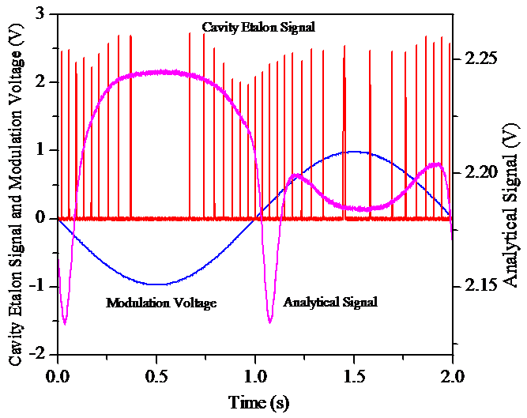

**Fig. 2.** *Sinusoidal curve: modulation voltage from the function generator, controlling the PZT of the ECDL and thereby the frequency of the laser light. Sharply peaked curve: cavity etalon signal obtained by scanning the laser while holding the last cavity fixed. The peaks correspond to longitudinal cavity modes, separated by 0.0760 cm-1 in UV. These two curves were used to calibrate the modulation voltage in terms of frequency. Smooth continuous curve: the uncorrected detector signal from the overlapping Q22(10.5) and QR12(10.5) transitions from 30 Torr of 100 ppm of NO in N2.*

In order to assess the sensitivity of the technique for detection of NO on the combined  and  transition, absorption signals were recorded for a set of pressures (from 6.6×10-3 to 0.86 atm, corresponding to 0.5 to 650 Torr) of the premixed 100 ppm NO/N2 gas mixture. The corresponding normalized net-analytical spectra from a set of such measurements are displayed in Fig. 3.

The collision widths for NO colliding with N2 at room temperature, taken from the curves shown in Fig. 3, are displayed in Fig. 4. As can be seen from the plot, the width is linear with pressure, which is in agreement with expectations. The slope, which corresponds to the collision broadening coefficient, it was found to be 0.581 cm-1/atm. This value is in good agreement with those of similar transitions of NO in this band assessed previously. For example, Chang *et al.* reported on a broadening coefficient of NO in N2 of 0.583 cm-1/atm [10], Hanna *et al.* gave a broadening coefficient of 0.557 cm-1/atm [11], Danehy *et al.* reported 0.586 cm-1/atm [12], whereas Anderson *et al.* reported 0.585 cm-1/atm for nearby transitions [13]. We thus find our value to be in good agreement with those previously reported, which supports the earlier as well as the presently reported measurements.

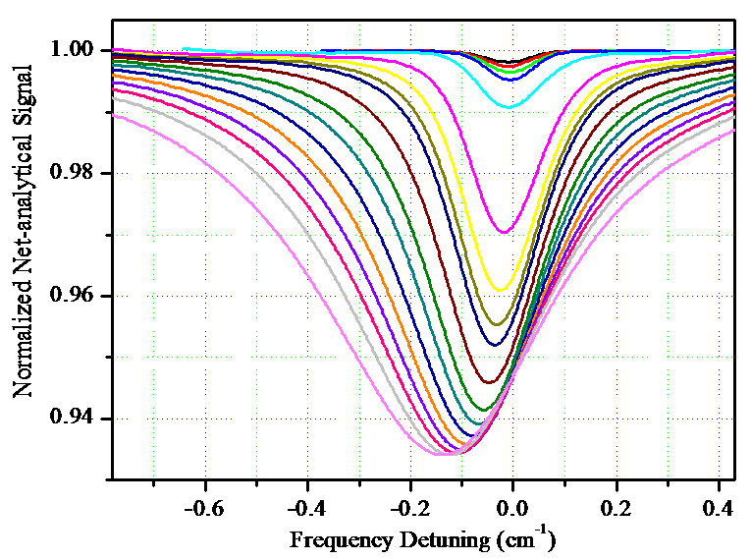

**Fig. 3**. *Normalized net-analytical spectra, for a set of total pressures of the 100 ppm NO/N2 gas mixture. The various curves represent total pressures of 0.5, 1.1, 2.1, 4.2, 16.1, 64.2, 100, 128, 148, 200, 256, 298, 349, 400, 448, 497, 554, and 650 Torr, respectively.*

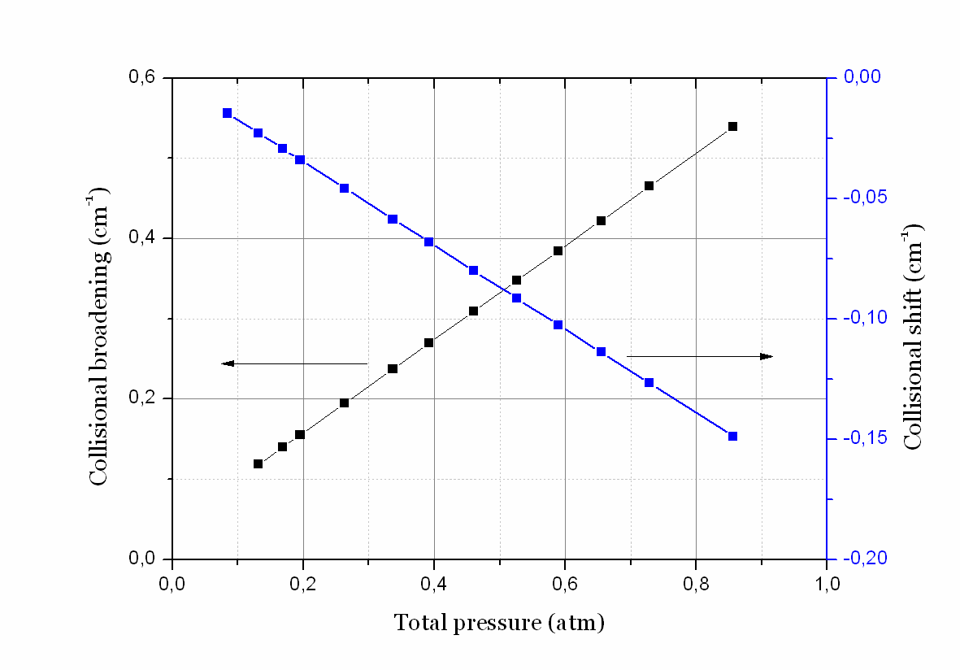

**Fig. 4**. *The collision broadening and collision shift of the targeted transition at room temperature, The collisional broadening and shift could be determined accurately (0.581 cm-1/atm and -0.174 cm-1/atm), repectively.*

It is also possible to assess the collision shift of the transition from fits to absorption curves such as those given in Fig. 3. Figure 4 shows a plot of the shift of the transition as a function of total pressure. The slope of the curve, which represents the shift coefficient of the transitions addressed in NO by collisions with N2, it was found to be ‑0.174 cm-1/atm. Also this is in reasonably good agreement with earlier published data of nearby transitions, e.g. that of Chang *et al.*, who reported -0.180 cm-1/atm [10].

1. **CONCLUSION**

Detection of nitric oxide at Torr pressures in a premixed gas with 100 ppm NO in N2 has been performed on an electronic transition at 226.577 nm by the use of fully-diode-laser-based ultraviolet absorption spectrometry utilizing balanced detection. Over an absorption path length of 10 cm, the minimum detectable partial pressure of NO was found to be 24 µTorr (for a data acquisition time of 5 sec and a S/N=3), corresponding to a relative concentration of 30 ppb, measured at an integrated absorption of 2.4×10-5 cm-1 and a minimum relative absorption of 2.3×10-4. This corresponds to a concentration path length of 3 ppb·m, which is a two orders of magnitude improvement of the detectability of NO by other diode-laser-based absorption spectrometric techniques.

The linestrength of the transitions addressed in this work was also found to be around four and two orders of magnitude larger than typical transitions previously addressed in the first and fundamental vibrational bands of NO (which have been assessed or estimated to 1.0×10-2 cm-2/atm and ~0.6 cm-2/atm, respectively). The linestrength of the transitions addressed in this work was even found to be a few times larger. This clearly indicates the large potential of UV TLDAS for detection of NO.

The instrumentation also allowed for a determination of the collision-broadening and shift coefficients of NO by N2 at room-temperature at the transitions targeted. These were found to be 0.581 and -0.174 cm-1/atm, respectively, which is in good agreement with previous assessments and which therefore confirm our as well as the previous assessments.

**ACKNOWLEDGMENTS.** This work was supported by SIDA under contract 7500728603/605/610 and the Swedish Research Council under project 621-2005-4919.

**REFERENCES**

[1] U.S. Environmental Protection Agency, "National air quality and emission trends report, 1998," EPA 454/R-01-004, U.S. Environmental Protection Agency, Office of Air Quality Planning and Standards, research Triangle Park, N.C. 2001.

[2] D. M. Sonnenfroh and M. G. Allen, "Absorption measurements of the second overtone band of NO in ambient and combustion gases with a 1.8-µm room-temperature diode laser," *Appl. Opt.* Vol. **36**, pp. 7970-7977.

[3] R. M. Mihalcea, D. S. Baer, and R. K. Hanson, "A diode-laser absorption sensor system for combustion emission measurements," *Meas. Sci. Technol.* Vol. **9**, pp. 327-338.

[4] D. B. Oh and A. C. Stanton, "Measurement of nitric oxide with an antimonide diode laser," *Appl. Opt.* Vol. **36**, pp. 3294-3297.

[5] M. Snels, C. Corsi, F. D'Amato, M. De Rosa, and G. Modugno, "Pressure broadening in the second overtone of NO, measured with a near infrared DFB diode laser," *Opt. Commun*. Vol. **159**, pp. 80-83.

[6] D. D. Nelson, M. S. Zahniser, J. B. McManus, C. E. Kolb, and J. L. Jimenez, "A tunable diode laser system for the remote sensing of on-road vehicle emissions," *Appl. Phys. B*. Vol. **67**, pp. 433-441.

[7] J. L. Jimenez, M. D. Koplow, D. D. Nelson, M. S. Zahniser, and S. E. Schmidt, "Characterization of on-road vehicle NO emissions by a TILDAS remote sensor," *J. Air Waste Manage. Ass*. Vol. **49**, pp. 463-470.

[8] J. L. Jimenez, G. J. McRae, D. D. Nelson, M. S. Zahniser, and C. E. Kolb, "Remote sensing of NO and NO2 emissions from heavy-duty diesel trucks using tunable diode lasers," *Environ. Sci. Technol.* Vol. **34**, pp. 2380-2387.

[9] C. Roller, K. Namjou, J. D. Jeffers, M. Camp, A. Mock, P. J. McCann, and J. Grego, "Nitric oxide breath testing by tunable-diode laser absorption spectroscopy: application in monitoring respiratory inflammation," *Appl. Opt.* Vol **41**, pp. 6018-6029.

[10] A. Y. Chang, M. D. Dirosa, and R. K. Hanson, "Temperature-dependence of collision broadening and shift in the NO A - X (0,0) band in the presence of argon and nitrogen," *JQSRT.* Vol. **47**, pp. 375-390.

[11] S. F. Hanna, R. Barron-Jimenez, T. N. Anderson, R. P. Lucht, J. A. Caton, and T. Walther, "Diode-laser-based ultraviolet absorption sensor for nitric oxide," *Appl. Phys. B.* Vol. **75**, pp. 113-117.

[12]. P. M. Danehy, E. J. Friedmanhill, R. P. Lucht, and R. L. Farrow, "The Effects of Collisional Quenching on Degenerate 4-Wave-Mixing," *Appl. Phys. B*. Vol. **57**, 1993, pp. 243-248.

[13]. T. N. Anderson, R. P. Lucht, R. Barron-Jimenez, S. F. Hanna, J. A. Caton, T. Walther, S. Roy, M. S. Brown, J. R. Gord, I. Critchley, and L. Flamand, "Combustion exhaust measurements of nitric oxide with an ultraviolet diode-laser-based absorption sensor*,*" *Appl. Opt.* Vol. **44**, 2005, pp. 1491-1502.