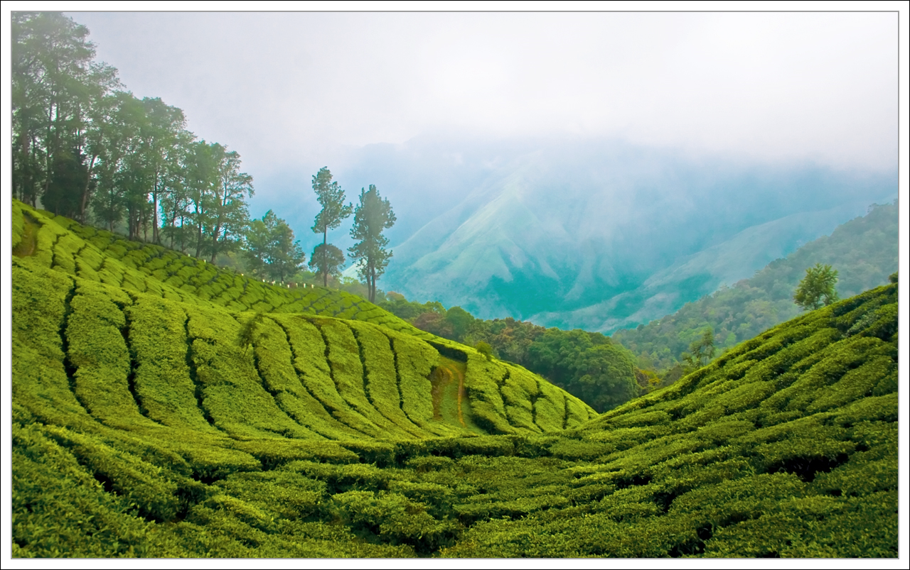
THE 6th ACADEMIC CONFERENCE ON NATURAL SCIENCE FOR YOUNG SCIENTISTS, MASTER AND PHD STUDENTS FROM ASEAN COUNTRIES (CASEAN - 6)  October 25-27, 2019, Thai Nguyen, Vietnam | Application for Exemption of the Conference Fees

A Details of the individual applying for the fee exemption
 | Name |  | Family name (surname) |  | Given names
 | Address and Email |  | Address  Email
 | Occupation and  Employment |  | Occupation  Institution  Work address

B Title of paper

 | C Supervisor’s recommendation
 |  | Name & Institution |  | Name |  | Institution
I highly recommend Mr/Mrs …………………………. for the exemption of CASEAN-6 conference fee.

