FORMAT FOR ABSTRACT

TITLE (14PT, BOLD, CENTERED)
(One blank line)
Presenting Author¹, Other Authors² (12 pt, Normal, Centered)
¹⁾ Department Name, Institute name, Institute addresses (11pt, Normal, Centered)
E-mail: (11pt, Normal, Centered)
(One blank line)
The abstract should be typed in 12 point, Times New Roman, normal font, single space, not over one page. Use A4 size paper with margins-top: 2.5 cm; bottom: 2.5cm; left: 3cm; and right: 2.5 cm. Cite the reference in parentheses e.g. Kotha et al [1] in the text. Reference should be typed in point, normal front, and single space. The entire abstract including text, figures, equations, structures, schemes and references must be sent as a MS-WORD DOC file.

Additional information on the 6th Academic Conference on Natural Science for Young Scientists, Master and PhD Students from Asean Countries (CASEAN - 6) can be found at http://www.iop.vast.ac.vn/activities/conf_asean/2015/

Abstracts should be sent to the conference e-mail address casean@iop.vast.ac.vn as a MS-WORD document file. The last date for submitting the abstracts is 30th July 2019.

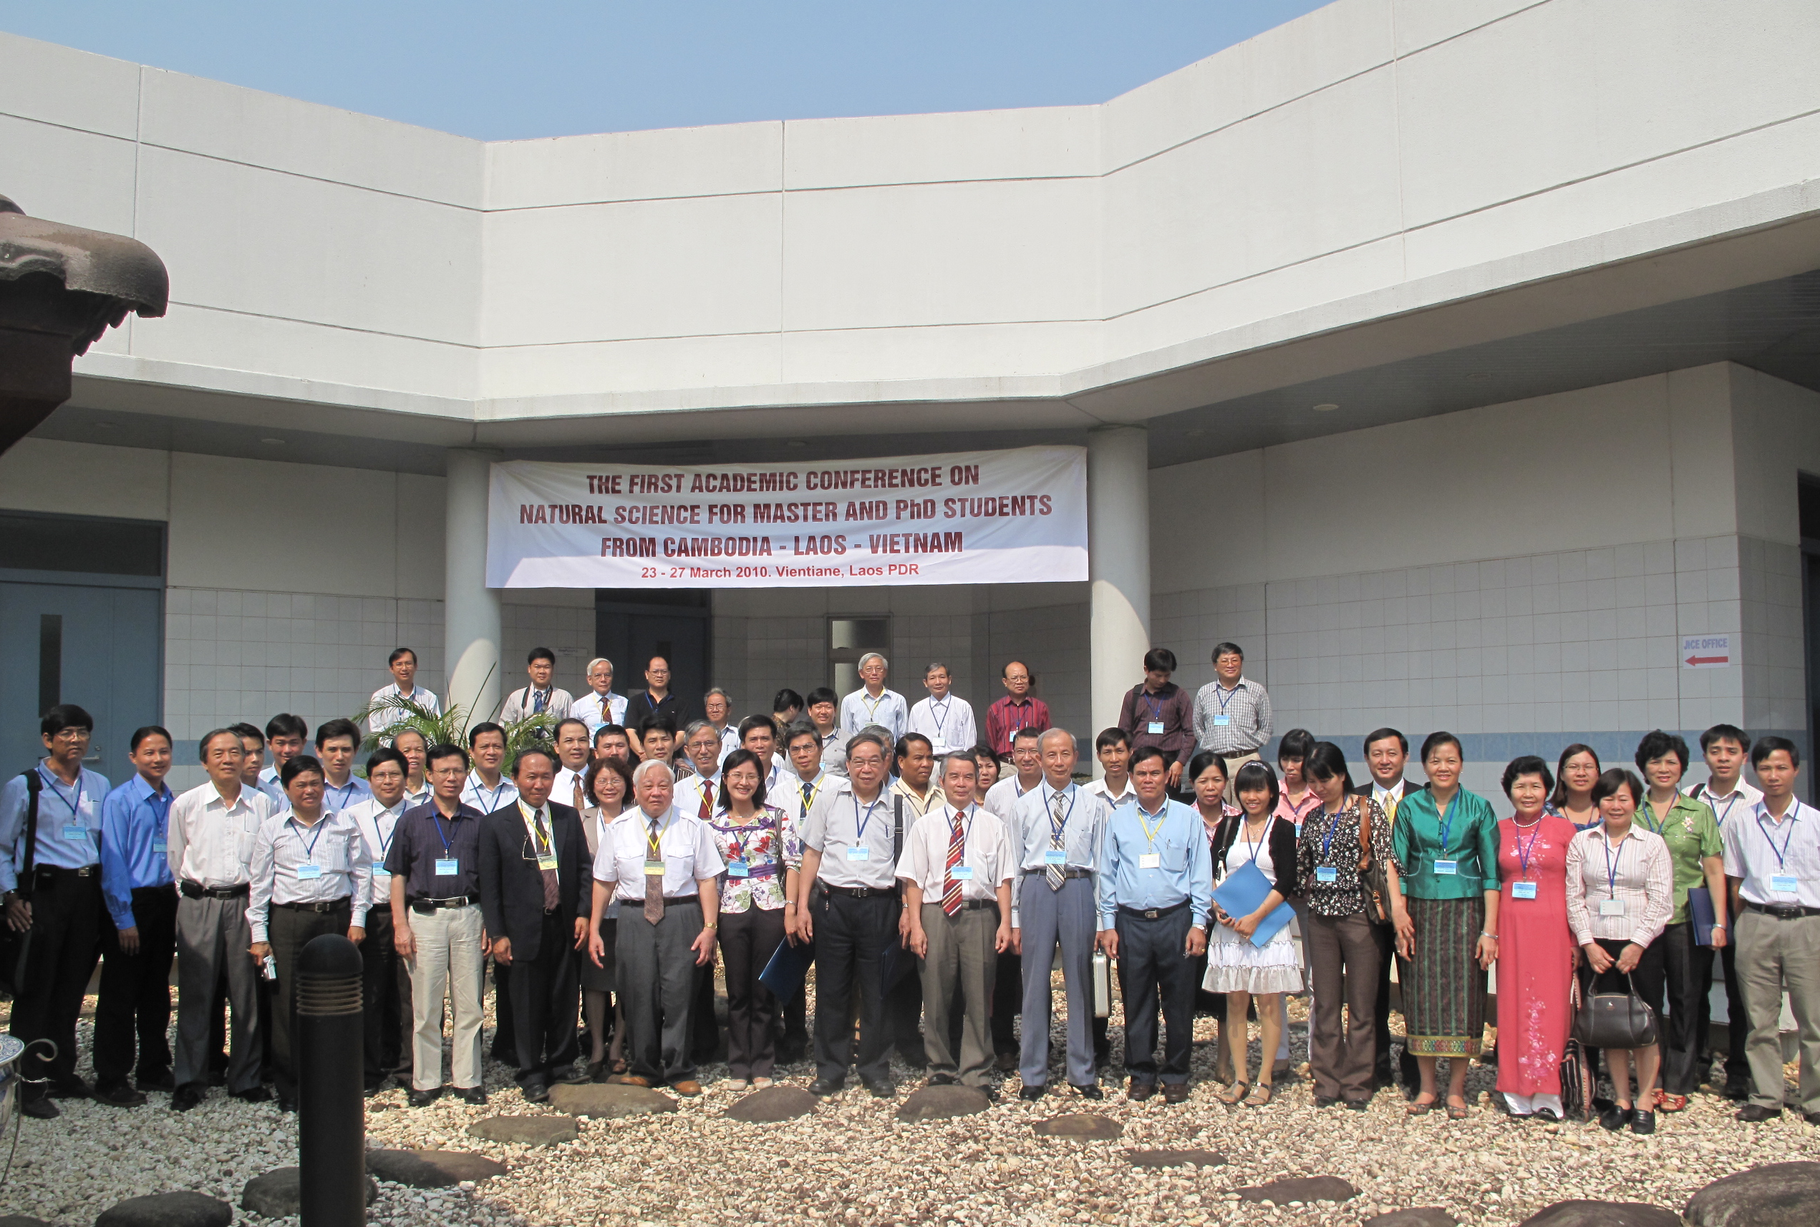
Fig. 1. The first Academic Conference on Natural Science

for Master and PhD Students from Cambodia - Laos - Vietnam

REFERENCES (12 POINT, bold)

- S. Kotha, K. Lahiri and K. Dhurke, Comm. in Phys. 22, 2009, pp. 9633[11 point, normal]

