(Title) The first Academic Conference on Natural Science

for Master and PhD Students from Cambodia - Laos - Vietnam

Author¹* and author²

¹ Affiliation
² Affiliation
*Email address: aaa@bbb.cc.dd

The first Academic Conference on Natural Science for Master and PhD Students from Cambodia - Laos – Vietnam will be held from 23 to 27 March 2010 in Vientiane, Laos. In the scope of the conference will be included the fields of natural sciences, such as Mathematics, Physics, Chemistry, Biology, Medicine, Computer Science and Engineering. The main purpose of the Conference is to provide a good opportunity for Master & PhD students, coming from universities and institutes in Vietnam, Laos and Cambodia to encourage and develop regional exchange activities, mutual understanding and co-operation in the fields of natural sciences and engineering as well as to stimulate scientific training and education.
At this conference, the participants can meet and interact with local and international funding agencies, motivational speakers, and peers and potential mentors. We invite potential Master & PhD students in all disciplines of Natural Sciences and Engineerings to attend The first Academic Conference on Natural Science for Master and PhD Students from Cambodia - Laos – Vietnam.

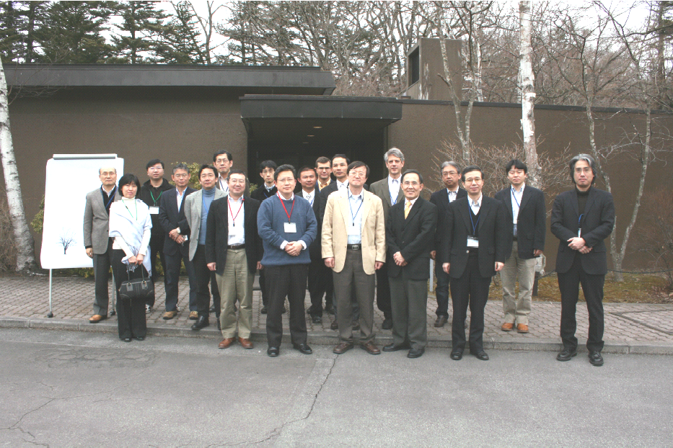
Fig. 1. The Symposium on Ultrafast Intense Laser Science in Karuizawa (March, 2009)
References
[1] A. B. APRI, Journal. 1, 1 (2008).

