TITLE OF THE PAPER

Brief, informative, and reflect the most important aspects of the article, in a preferably concise form of not more than 100 characters and spaces. Font type Time New Roman, size 14, bold, capital letters, center alignment.
(one blank line)
Author *ª, Author^{b} and Author^{c}
No inclusion of scientific titles is necessary. In case of two or more authors, place their names in the same row, separate them with a comma. Indicate the E-mail author with * in superscript. Font type Time New Roman, size 12, bold, center alignment.
ªInstitution and address, ^{b}Institution and address, ^{c}Institution and address
Authors from different institutions must be organized with alphabet character in superscript after the names. Font type Time New Roman, size 11, italic, title case letters, center alignment.
(one blank line)
Abstract: The objective, the principal methods, the principal results and conclusions are summarized. The abstract must be self-explanatory, typed in one paragraph and limited to max. 200 words. It should not contain formulas and references. Font type Time New Roman, size 11, regular (bold and sentence letters are only the word abstract), justify.

Keywords: Should not exceed five, not including items appearing in the title. The keywords should be supplied indicating the scope of the paper, appearing in the abstract, and arranged in alphabetical order. Font type Time New Roman, size 11, regular, lowercase letters (bold and sentence letters are only the word keywords).

INTRODUCTION (12 POINT, bold)
The introduction must clearly state the problem, the reason for doing the work, the hypotheses or theoretical predictions under consideration and the essential background. A brief survey of the relevant literature, so that a non-specialist reader could understand the significance of the presented results. Text of the introduction with references to literature [x]. Font type Time New Roman, size 12, regular, sentence letters, justify (bold, capital letters and left align are only the word introduction).

MATERIALS AND METHODS (12 POINT, bold)
Subsection title
Provide sufficient details to permit repetition of the experimental work. The technical description of methods should be given when such methods are new. Text with references to literature [x] and figures (Fig. y) if any. Font type Time New Roman, size 12, regular, sentence letters, justify (bold, capital letters and left align are only the word materials and methods), (bold, sentence letters and left align are only the subsection, if any).

RESULTS AND DISCUSSION (12 POINT, bold)
Subsection title
Results should be presented concisely. Only in exceptional cases will it be permissible to present the same set of results in both table and figure. Each figure or table should be numbered and have a caption. Figure’s caption placed below figure, font type Time New Roman, size 11, italic, sentence letters, justify. Table’s caption placed above table, font type Time New Roman, size 11, italic, sentence letters, left align. Point out the significance of the results, and place the results in the context of other work and theoretical background. Text with references to figures (Fig. y) and/or tables (Table z) if any, and literature [x]. Font type Time New Roman, size 12, regular, sentence letters, justify (bold, capital letters and left align are only the word results and discussions), (bold, sentence letters and left align are only the subsection, if any).
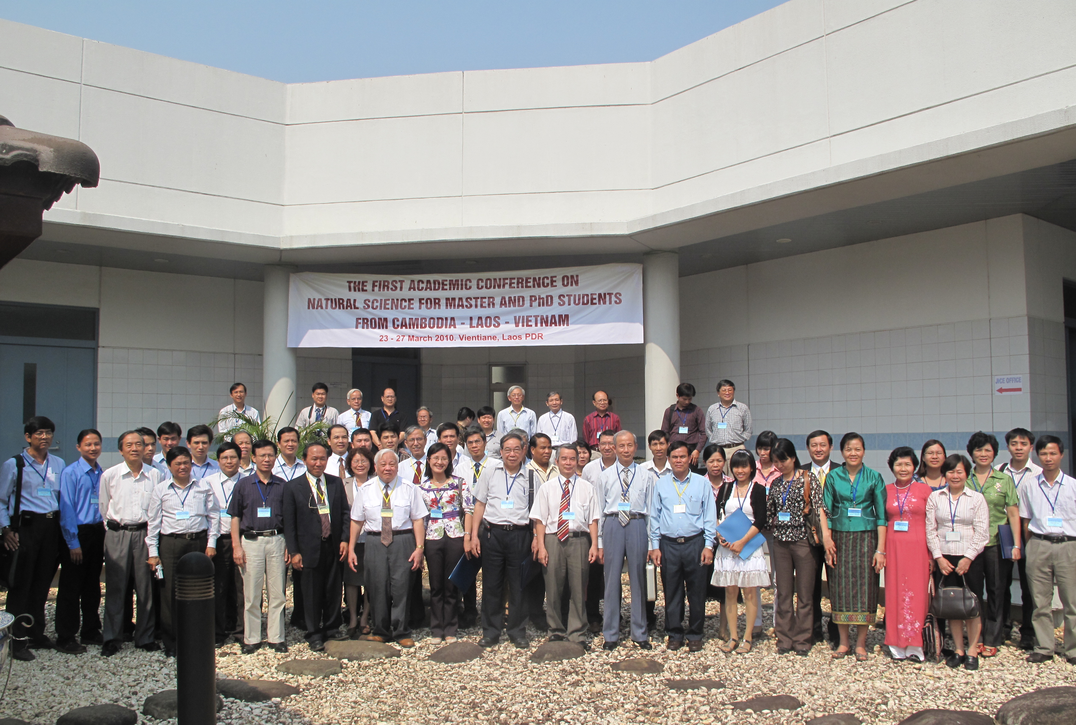
Fig. 1. The first Academic Conference on Natural Science
for Master and PhD Students from Cambodia - Laos – Vietnam
Table 1. The <cos² θ> values of the fragment ions, H_{n}⁺ and the parameters obtained by least-squares fits of Eq. (6)
Explosion pathways | θ_{m}⁰/deg | τω | τ /ps | <cos² θ>
C₃H₃⁺ + H⁺ (n = 1)  C₃H₂⁺ + H₂⁺ (n = 2)  C₃H⁺ + H₃⁺ (n = 3) | 29(2)  23(2)  12(4) | >5.0  >5.0  3.2 (1.1) | >1.9  >1.9  1.2(4) | 0.37  0.38  0.39

The papers should be written in English, set up for A4 pages with margins-top: 1 inch; bottom: 1 inch; left: 1.25 inches; and right:1 inches and not over 04 pages.

CONCLUSIONS
Text of the conclusions. Font type Time New Roman, size 12, regular, sentence letters, justify (bold, capital letters and left align are only the word conclusions).

Acknowledgements: (if any text limited to 200 words). These should be placed in a separate paragraph at the end of the text, immediately before the list of references. It may include funding information too. Font type Time New Roman, size 11, regular (bold and sentence letters are only the word acknowledgements), justify.

REFERENCES (12 POINT, bold)

At the end of the paper list references by the last name of the first author. Please list only those references that are cited in the text and prepare this list as an automatically numbered list. Font type Time New Roman, size 11, regular (bold and sentence letters are only the word references), justify. In the text references should be cited by their number in the list in brackets (e.g. [1] ). Cite only essential resources, avoid citing unpublished material. References to papers “in press” must mean that the article has been accepted for publication. The list should contain names and initials of all of the authors.

- Hishikawa, H. Hasegawa, and K. Yamanouchi, J. Electron Spectrosc. Relat. Phenom. Vol. 141, 2004, pp. 195-200.
- T. Kato, K. Yamanouchi, J. Chem. Phys. Vol. 131, 2009, pp.164118(1-14).

