FORMAT FOR ABSTRACT

TITLE (14PT, BOLD, CENTERED)
(one blank line)
Presenting Author*ª, Other Authors^{b} (12pt, Normal, Centered)
^{a)} Department Name, Institute name, Institute addresses (11pt, Normal, Centered)
E-mail: (11pt, Normal, Centered)
(one blank line)
The abstract should be typed in 12 point, Times New Roman, normal font, single space, not over two pages. Use A4 size paper with margins-top: 1 inch; bottom: 1inch; left: 1.25 inches; and right:1 inches. Cite the reference in parentheses e.g. Kotha et al [1] in the text. Reference should be typed in point, normal front, and single space. The entire abstract including text, figures, equations, structures, schemes and references must be sent as a MS-WORD DOC file. The printed area should be 5.8 inches (W) × 9.7 inches (L).

Additional information on the 2nd Academic Conference on Natural Science for Master and PhD Students from Cambodia, Laos, Malaysia and Vietnam (CLV-02) can be found at http://www.iop.vast.ac.vn/activities/clv02/.

Abstracts should be sent to the conference e-mail address clv02@iop.vast.ac.vn as a MS-WORD document file. The last date for submitting the abstracts is 14th September 2011.

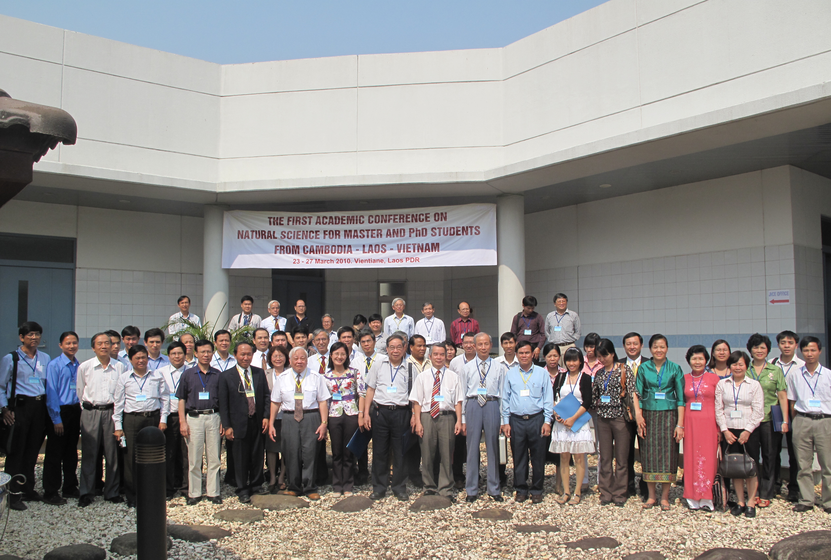
Fig. 1. The first Academic Conference on Natural Science

for Master and PhD Students from Cambodia - Laos - Vietnam

REFERENCES (12 POINT, bold)

- S. Kotha, K. Lahiri and K. Dhurke, Comm. in Phys. 22, 2009, pp. 9633[11 point, normal]

