Ultrafast hydorgen migration in allene induced
by an intense femtosecond laser field

Huailiang Xu, Tomoya Okino, Kaoru Yamanouchi
School of Science, The University of Tokyo, 7-3-1 Hongo, Bunkyo-ku, Tokyo, 113-0033, Japan. E-mail: kaoru@.......

Abstract. Ultrafast hydrogen migration in allene (CH₂=C=CH₂) induced by intense laser fields was investigated by Coulomb explosion coincidence momentum imaging (CMI)...
Key word: Hydrogen migration, Allene, Intense laser field.

I. INTRODUCTION

During the past few years, an ultrafast hydrogen migration process within a molecule in intense laser fields has been an attractive research theme, not only because of the findings that hydrogen atoms (or protons) move extremely rapidly within a molecule, but also their potential applicability for controlling chemical bond breaking processes [1, 2]…

II. EXPERIMENTS

The schematic diagram of the experimental setup used in this experiment is shown in Fig. 1. The light source used in the experiments was a Ti:Sapphire femtosecond laser system (Pulsar 5000, Amplitude Technologies)…

III. RESULTS AND DISCUSSION

Figure 1 shows the recorded time-of-flight (TOF) mass spectrum of the ionic species generated from C₃H₄ in the intense laser field…
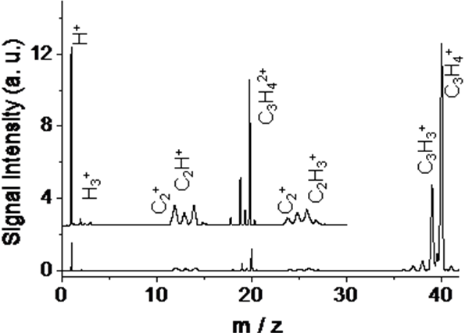
Signal Intensity (a.u.)
m /z

Fig.1. Time-of-flight mass spectrum of allene in an intense laser field (40 fs, 2×10¹³ W/cm²).

The momentum imaging maps of CH_{m}⁺ (m =1-3) appearing in coincidence with C₂H_{4-m}⁺ are shown in Figs. 3a-3c, which represent the two-body Coulomb explosion pathways Eq. (1).
$I(θ)=1+\sum_{L}{b_{L}\prod_{k=1}^{L/2}{\frac{{\left(1/{\text{τω}}\right)}^{2}+{\left(2k−1\right)}^{2}}{{\left(1/{\text{τω}}\right)}^{2}+{\left(2k\right)}^{2}}}P_{L}(\text{cos} θ_{m}^{0})P_{L}(\text{cos} θ)}$ (L= 2, 4, 6) (6)
where P_{L} denotes the Legendre polynomial and b_{L} reflects the angular distribution of the molecular principal axis of the parent molecules with respect to the laser polarization direction.

Table 1. The <cos² θ> values of the fragment ions, H_{n}⁺ and the parameters obtained by least-squares fits of Eq. (6)
Explosion pathways | θ_{m}⁰/deg | τω | τ /ps | <cos² θ>
C₃H₃⁺ + H⁺ (n = 1)  C₃H₂⁺ + H₂⁺ (n = 2)  C₃H⁺ + H₃⁺ (n = 3) | 29(2)  23(2)  12(4) | >5.0  >5.0  3.2 (1.1) | >1.9  >1.9  1.2(4) | 0.37  0.38  0.39

IV. CONLUSION

The two-body and three-body Coulomb explosion of allene induced by an ultrafast intense laser field has been investigated by using the coincidence momentum imaging method…

V. ACKNOWLEDGMENTS

The present research was supported by two grants from the Ministry of Education, Culture, Sports, Science and Technology (MEXT)…

References

[1] A. Hishikawa, H. Hasegawa, and K. Yamanouchi, J. Electron Spectrosc. Relat. Phenom. Vol. 141, 2004, pp. 195-200.
[2] T. Kato, K. Yamanouchi, J. Chem. Phys. Vol. 131, 2009, pp.164118(1-14).
…

