Phuong Dong Hotel
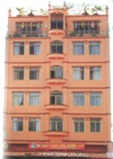 | Address : 62, 30/ 40 street, Can Tho City, Vietnam.  Tel: +84.71.812 199 / 812 200/ 812 399  Fax: +84.71.820 133  Email:phuongdonghotel@hcm.vnn.vn  Description : Officially opened in June, 2000, Phuong Dong Hotel is one of the hotels that reach the international standard in the Mekong Delta. Phuong Dong hotel is situated in the centre of Cantho city, some minutes far from Ninh Kieu Wharf - a well known landscape all over the country - and meantime, from here tourists will easily go to others trading centre and financial transactions of Cantho city.  Rates (*)  (*) Room rate is inclusive of SVC, VAT, daily buffet breakfast, mineral water, and fruit  Free of charge up to children under 12 years old in parent room.  Credit cards (Visa, JCB, Master, Amex), demand deposit, cash are accepted to
  Room types | Prices
  Room types | Foreigner | Vietnamese
  Suite | 38 USD | 380 000 VND
  Deluxe | 29 USD | 290 000 VND
  Superior | 25 USD | 250 000 VND
  Standard | 19 USD | 190 000 VND
  Tripple | 30 USD | 300 000 VND
  Family | 40 USD | 400 000 VND
Cuu Long Hotel
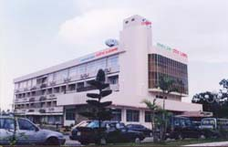 | Address : 52 Quang Trung street, Can Tho City, Vietnam.  Tel: +84.71.822 669 / 820300 - Fax: +84.71. 820157  Located on 5000 m2,large car park (over 200 car in safe place), beautiful view and quiet place with 80 rooms meet 2 star international standard.  Rates (*):  Air-conditioner, refrigerator, bathtub, TV with the international chanels, warm water machine , Tel .  (But there is no bathtub and refrigerator for Type 3)  (*) Room rate is inclusive of SVC, VAT and breakfast
  Room types | Capacity | Prices
  Room types | Capacity | Foreigner | Vietnamese
  Special type | 20 rooms (1 or 2 persons/ room) | 27 USD | 270 000 VND
  Type I | 26 rooms (1 or 2 persons/ room) | 25 USD | 250 000 VND
  Type II | 22 rooms (1 or 2 persons/ room) | 20 USD | 200 000 VND
  Type III | 20 rooms | 16 USD | 160 000 VND
Tay Do Hotel
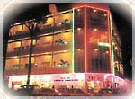 | Address : 61 Chau Van Liem Street, Can Tho City  Tel: (+84 71) 821009 - Fax: (+84 71) 827008  International standard class hotel located in the center of Can Tho City. The Tay Do Hotel has 31 rooms and a restaurant serving Vietnamese, Chinese and Western dishes.  Rates(*) :  (*) Room rate is inclusive of SVC, VAT and breakfast
  Room types | Foreigner | Vietnamese
  Deluxe | 20 USD | 200.000 VND
  Superior | 18 USD | 180.000 VND
Hau Giang Hotel
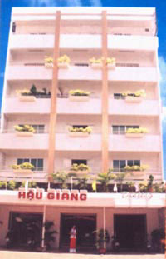 | Address : 34 Nam Ky Khoi Nghia, Can Tho City, Vietnam.  Tel: +84.71.821851  Fax: +84.71.821806  Email: haugiang@hcm.vnn.vn  Located in the heart of the city, near by bank, market, governmental bodies,…  Rates : from 10 USD to 25 USD
Number 2 Hotel
Address : 5 Hai Ba Trung street, Can Tho City
Tel: (+84 71) 811 619 - Fax: (+84 71) 814 258
Rates(*) :
Room types | Facilities | Foreigner | Vietnamese
Type I  (18 rooms) | Air-conditioner, refrigerator, bathtub  satellite TV, IDD tel, cold- warm water, hair-dryer, dressing-table | 23 USD | 230.000 VND
Type II  (08 rooms) | Air-conditioner, bathtub satellite TVl, IDD tel, cold- warm water machine, hair-dryer, dressing-table | 15 USD | 150.000 VND
(*) Room rate is inclusive of VAT and breakfast
Ngan Ha Hotel
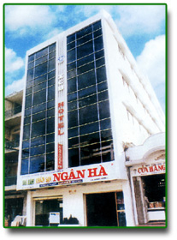 | Address : 39-41 Ngo Quyen street, Can Tho City  Tel: (+84 71) 821024 / 822921 - Fax: (+84 71) 813 396  Located in the center of Can Tho city, 100m from Ninh Kieu riverbank, the hotel equipped full - modern facilities to meet international standard  Rates :
  Room types | Facilities | Foreigner | Vietnamese
  Type I | Air-conditioner , hot water, refrigerator, TV, bathtub, Tel | 24 USD | 240.000 VND
  Type II | Air-conditioner , hot water, refrigerator, TV, Tel | 20 USD | 200.000 VND
  Type III | Air-conditioner , TV, Tel | 10 USD | 110.000 VND
Asia Hotel
Address : 91 Chau Van Liem Street, Can Tho City
Tel: (+84 71) 812 800 / 812 808 - Fax: (+84 71) 812 779
Email: asiahotel@hcm.vnn.vn
Rates(*) :
Room types | Facilities | Foreigner | Vietnamese
Special  (6 rooms) | 1 double bed+1 single bed, air-conditioner, Satellite TV, bathtub, IDD Tel, warm - cold water machine, balcony, Amenities (toothpaste, toothbrush, shampoo, comb,..) | 29 USD | 290.000 VND
Type I  (7 rooms) | 2 single beds, air-conditioner, Satellite TV, bathtub, IDD Tel, warm - cold water machine - balcony - Amenities (toothpaste, toothbrush, shampoo, comb,..) | 25 USD | 250.000 VND
Type II  (9 rooms) | 1 double bed, air-conditioner, Satellite TV, IDD Tel, warm - cold water machine, Amenities (toothpaste, toothbrush, shampoo, comb,..) | 20 USD | 200.000 VND
(*) Room rate is inclusive of services, VAT and breakfast
Tri Thien Hotel
Address : 138C Ly Tu Trong Street, Can Tho City
Tel: (+84 71) 731 388 / 731 399 - Fax: (+84 71) 731 366
Rates :
Room types | Facilities | Foreigner | Vietnamese
VIP | Air-conditioner, bathtub, satellite TV, tel,  Cold-warm water machine, balcon | 40 USD | 400.000 VND
Deluxe |  | 35 USD | 350.000 VND
Superior |  | 30 USD | 300.000 VND
Standard |  | 25 USD | 250.000 VND

Hoa Binh Hotel
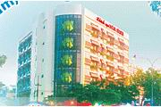 | Address : 5, Hoa Binh Boulevard, Can Tho City, Vietnam.  Tel: +84.71.810 218 / 820 536  Fax: +84.71.810 217  Email: contact@hoabinhct.com  Website: http://www.hoabinhct.com  Description : located on the most beautiful boulevard of the city, near by bank, market, governmental bodies,…  Rates
  Room types | Equipment | Prices
  Room types | Equipment | Foreigner | Vietnamese
  Suite double | Bedroom +living room+ air-conditioner + cable television + tel + warm - cold water machine + bathtub | 45 USD | 450 000 VND
  Deluxe | Bedroom + air-conditioner + cable television + tel + warm - cold water machine + bathtub | 30 USD | 350 000 VND
  Superior | Bedroom + air-conditioner + cable television + tel + warm - cold water machine + bathtub | 28 USD | 270 000 VND
  Standard | Bedroom + air-conditioner + cable television + tel + warm - cold water machine | 20 USD | 200 000 VND
Saigon Can Tho Hotel

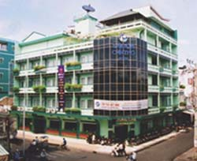 | Address : 55 Phan Dinh Phung Street, Can Tho City, Vietnam.  Tel: +84.71.825 831 / 822 318  Fax: +84.71.823 288  Email: info@saigon-cantho.com  Website: www.saigon-cantho.com\  Description : Strategically located in the heart of Cantho city. Saigon-Cantho Hotel offers easy access to financial and goverment offices, shopping and entertainment areas, and Ninh Kieu quay in walking distance.  Rates (*)  (*) Room rate is inclusive of SVC, VAT and daily buffet breakfast  Extra bed at room: 10 USD/ foreigner and 30.000 VND/ Vietnamese
  Room types | Capacity | RACK RATE  (Foreigner) | Corporate rates for RIVF
  Room types | Capacity | RACK RATE  (Foreigner) | Single |  | Twin
  Room types | Capacity | RACK RATE  (Foreigner) | Foreigner | Vietnamese | Foreigner | Vietnamese
  Superior | 46 twin rooms | 55 USD | 35 USD | 250 000 VND | 40 USD | 280 000 VND
  Deluxe | 46 twin rooms | 62 USD | 40 USD | 300 000 VND | 45 USD | 330 000 VND
Ninh Kieu Hotel
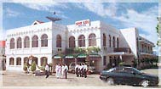 | Address: 2 Hai Ba Trung Street, Can Tho City  Tel: (+84 71) 824583 - Fax: (+84 71) 821104  Located at the fork of CanTho river, NinhKieu quay, central area of CanTho city. Built in the ancient French architectural style.  Rates:
  Room types | Foreigner | Vietnamese
  Deluxe Suite *** | 80 USD | 600.000 VND
  Deluxe *** | 45 USD | 450.000 VND
  Superior *** | 40 USD | 330.000 VND
  Standard *** | 35 USD | 300.000 VND
  Type I ** | 30 USD | 250.000 VND
  Type II ** | 25 USD | 200.000 VND
International Hotel
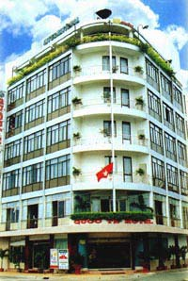 | Address : 12 Hai Ba Trung Street, Can Tho City, Vietnam.  Tel: +84.71.822079 / 822080  Fax: +84.71.821039  Email: ksquocte-ct@hcm.vnn.vn  Description : Located in the heart of the city on Ninh Kieu wharf, only fews minutes to the market, General Post Office, Bank, Provincial Government bodies,....  Rates (*)
  Room types | Facilities | Rates | Discount rates
  Room 210 | Twin room, Air - condition  IDD Telephone, Bath tub, Hot water  Satellite T.V, fridge, hair dryer | USD 71 | USD 35
  Special class (04 rooms)  (River view - Balcony) | Double bed, Air - condition  IDD Telephone, Bath tub, Hot water  Satellite T.V, fridge, hair dryer | USD 57 | USD 28
  First class (15 rooms)  (River view) | Double bed, Twin room, Air - condition  IDD Telephone, Bath tub, Hot water  Satellite T.V, fridge, hair dryer | USD 47 | USD 25
  Second class (21 rooms)  (Back side) | Twin room, Air - condition, Hot water  IDD Telephone, Satellite T.V, fridge | USD 36 | USD 19

